Task 4.1

Diagram:
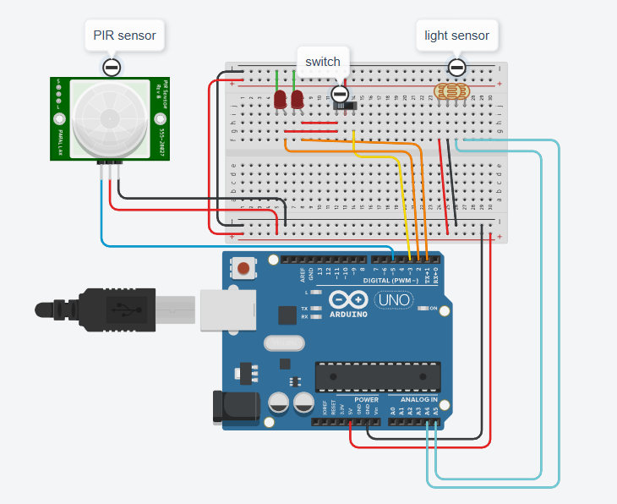

Serial Output:
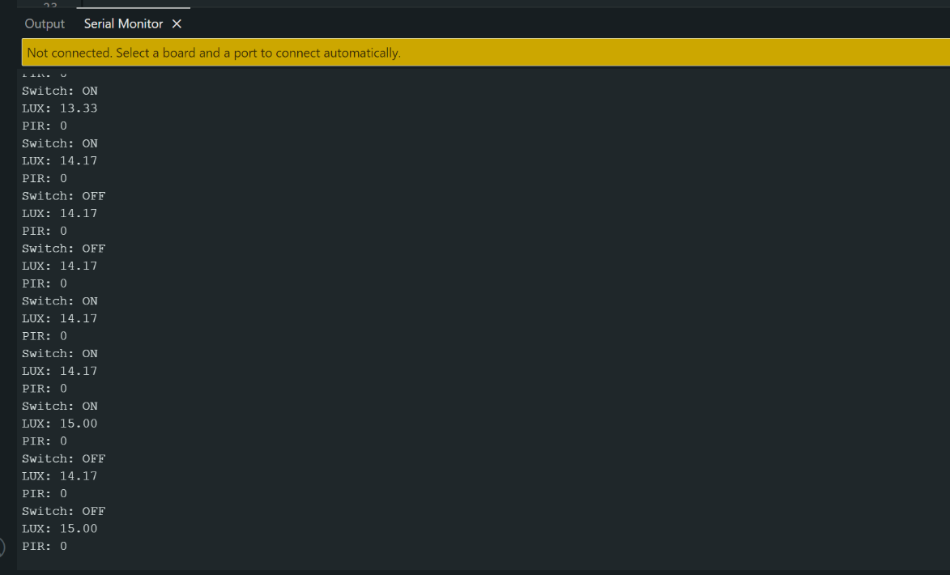

GitHub link: https://github.com/charlieM044/SIT210/tree/main/task%204.1/PIR_LIGHTSENSOR_SWITCH
Video link: https://deakin.au.panopto.com/Panopto/Pages/Viewer.aspx?id=421973a9-a6a5-4945-b6f8-b417002e499d

